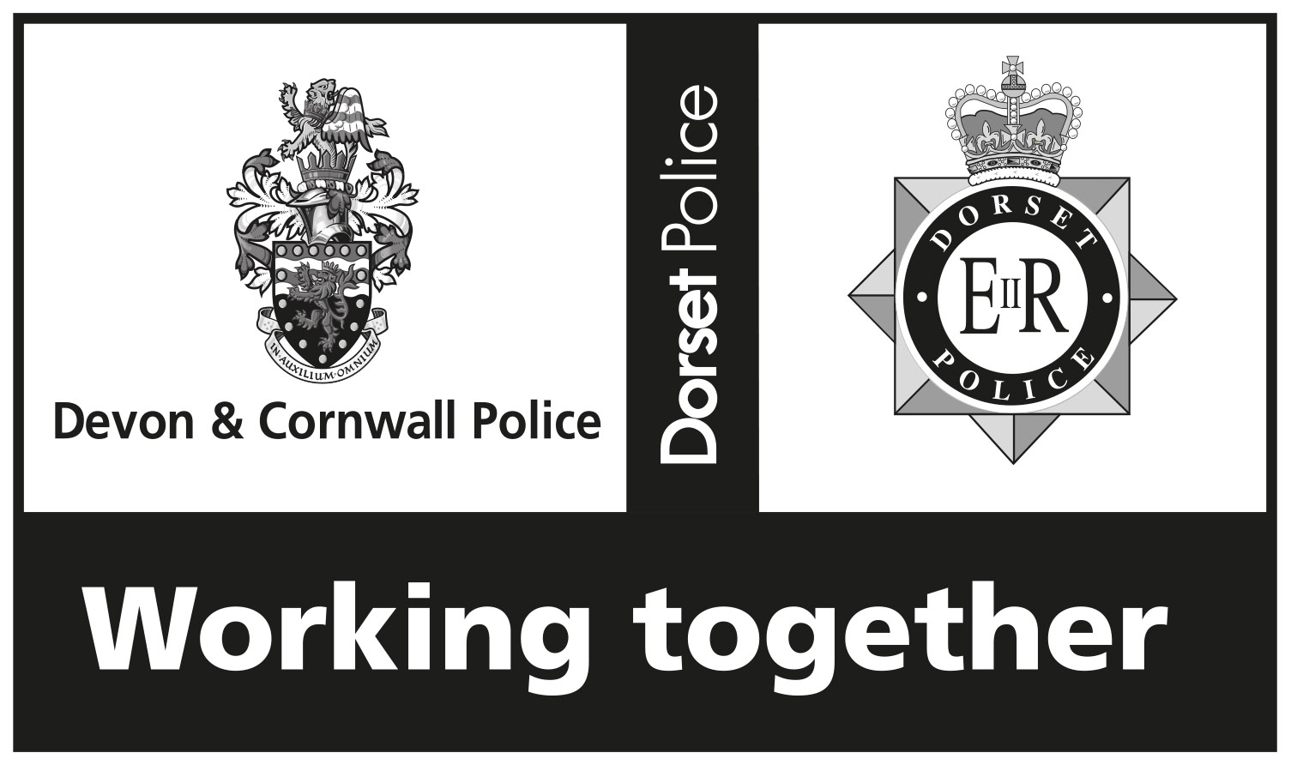 | In Strictest Confidence  Equality Monitoring Form  Devon & Cornwall Police and Dorset Police | Form EOM(2)  V2 06/2018  Application Stage

Post
Police Officer | Police Staff | PCSO |  | Special Constable |  | Cadet
Relief Worker | Agency Worker |  | Volunteer |  | Independent Advisor |  | Apprentice
Job title: Volunteer
Devon & Cornwall Police and Dorset Police are committed to being equal opportunity employers. In accordance with advice received from the Equality and Human Rights Commission each Force monitors all the applications it receives for the posts which it advertises. The information provided is for monitoring purposes and is not considered in the selection process.
Devon & Cornwall Police and Dorset Police are committed to promoting genuine equality of opportunity in line with our responsibilities under the Equality Act 2010 and the Public Sector Equality Duty. In order to promote genuine equality of opportunity we need an overview of our applicants. We try to ensure that any request for personal information from you is necessary and proportionate. All personal information is stored securely in line with the requirements of Data Protection legislation.
If you are successful in your application the information you provide will be transferred to your personnel record. The information is used to help us understand the make-up of our workforce and informs our positive action activity to help us achieve a more representative workforce. Access will be restricted to authorised staff only. You can update your personal confidential data at any time.
Please place a cross in all the relevant boxes:
1. Age
Under 16 | 16-25 | 26-35 | 36-45 |  | 46-55
56-65 | 66+ | Prefer not to say

2. Disability
The Equality Act defines a person as having a disability if he or she ‘has a physical or mental impairment, which has a substantial and long term adverse effect on his or her ability to carry out normal day-to-day activities’.
Do you have such a disability? Yes No
Please indicate if you will require any assistance or reasonable adjustments if you are invited for testing and / or an interview; we will be pleased to discuss this with you.

3. Ethnic origin
How would you describe my ethnic origin?
White: | British Irish Irish Traveller  Any other White background (please specify):
Mixed: | White & Black Caribbean White & Black African White & Asian  Other mixed background (please specify):
Asian / Asian British: | Indian Pakistani Bangladeshi  Other Asian background (please specify):
Black / Black British: | Caribbean African  Other Black background (please specify):
Other: | Chinese  Any other ethnic group (please specify):
Prefer not to say:

4. Gender identity
Is your gender identity the same as it was at birth?
Yes No Prefer not to say

5. What is your religion or belief?
Atheism Baha’i Buddhism
Christianity Hinduism Humanism
Islam Jainism Judaism
Pagan Parsi / Zorastrianism Rastafarianism
Sikhism Other religion or belief (please specify):
No religion or belief Prefer not to say

6. Gender
Male Female Other: Prefer not to say

7. Sexual orientation
Heterosexual Bisexual Lesbian Gay
Other: Prefer not to say

