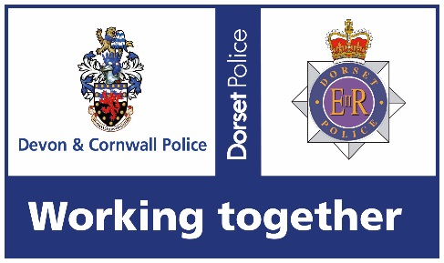 | DEVON & CORNWALL POLICE

Job Title: | Police Constable Police Driving Instructor
Job Type: | Permanent
Number of Hours: | 40
Post Number: | P3897
Based at: | Force wide (Bodmin / Plymouth / Exeter)
Principal Responsibility: | The delivery of core and specialist driver training as prescribed by the College Of Policing Police Driving, National Policing Curriculum. With particular reference to:-  - Dealing with the associated risks involved in instructing high performance and police exemption training.  - Acting as single point of contact for specialist courses when required.  - Conducting instruction, evaluation and assessing of personnel as required, making decisions as to the candidate’s competence to pass the course.  - Managing the dynamic nature of driving instruction and the control required.  - Preparing and presenting evidence of candidates’ suitability for courses, training needs and further progress by use of development plans.  - Ensuring driving records are updated accordingly.  - Delivering other police driver training as necessary in line with the role holder’s qualification.  - Ensure that equality and diversity standards and requirements are fully considered and implemented appropriately throughout practice and process.  - Act as a Subject Matter Expert for the organisation, in conjunction with maintaining practical effectiveness and competence, assisting in the provision of operational resilience if required.  - Engage in the design, development and delivery of a wide range of learning interventions depending on the complexity or scope of the subject matter area.  - Promote individual ownership for continuing professional development.  - Ensure that quality assurance standards are present, used and embedded in line with the College of Policing.  - Monitoring national, regional and local developments in training delivery methods and innovative ways of learning.  - Expectation is that all instructors will complete and maintain a minimum of 4 weeks CPD a year. This will mean abstractions from core roles for our resilience instructors.
Qualifications: | Must be a Police Advanced Driver  Must meet the College of Policing standard for Instructors  Must meet the College of Policing standard for assessors
Additional information | Essential experience, specialist skills and knowledge  - Must be a current Police driving instructor  - Up to date knowledge of current driving legislation  - Experience of working unsupervised  - Basic IT skills  - Excellent communication skills  Preferable experience, specialist skills and knowledge  - Experienced in Police driving instruction  - Be an advanced driving instructor  - Be a TPAC instructor
Job Contact Details: | For further information please contact  A/Inspector Dan LEWIN,  Chief Driving Instructor  Daniel.lewin@devonandcornwall.pnn.police.uk
Support for candidates | Resourcing Team Please contact the team via email to DCP-UniformedRecruitment@DevonandCornwall.PNN.Police.uk with any queries you may have in respect of the selection process – the team will be happy to assist.  Reasonable Adjustments Candidates who consider themselves to have a disability, as defined under the Equality Act 2010, and those who have any specific needs that may impact on their ability to complete any part of a selection process (for example the application form or to undertake a structured interview and any related assessments/tests) may be considered for a reasonable adjustment as part of a selection process. Candidates must detail their request for reasonable adjustments on the ‘Intention to Apply’ form. This request will be considered by the Resourcing Team who will provide advice and consultation to the individual as necessary.  Disability Confident Scheme The Force is proud to be accredited under the Disability Confident Scheme. Under the Scheme candidates can apply for vacancies under the Guaranteed Interview Scheme which entitles candidates to be invited to interview provided they meet the essential requirements of the role. Candidates must indicate on the ‘Intention to Apply’ form if they are applying under the scheme.  Positive Action Driver Training is supported by the positive action team. There is a range of support initiatives that our Force can provide to people from under-represented groups, where applications are specifically welcome. Access Positive Action Support

