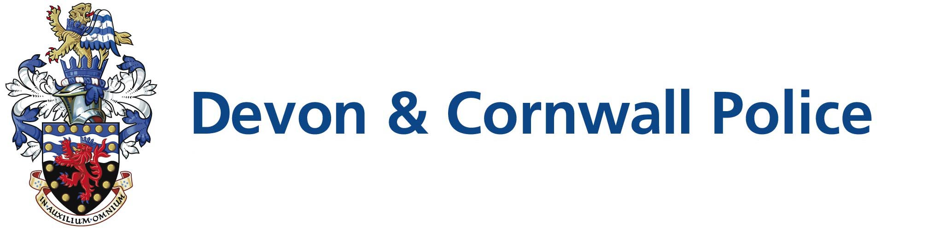

Police Support Volunteer (PSV) Role Profile

Role Title: | Health & Wellbeing Team Support Volunteer
BCU/Dept: | Resourcing & Development Devon and Cornwall Police
Hours | Flexible

Scheme Description
  Health & Wellbeing Support Volunteers help to support Health and Wellbeing initiatives within Devon and Cornwall Police. This role plays a key part in passing on information and advice in order to maintain and enhance the overall Health and Wellbeing of Police employees.

In this role the volunteer will assist with:
Role Description | - Delivering Healthy Lifestyle sessions utilising the Tanita Body monitoring equipment. Offering nutrition, fitness and relaxation advice and signposting staff to available resources that will help to enhance Wellbeing  - Assistance with planning, and attendance at, local Wellbeing events aimed at providing additional support and advice to staff.  - Support Health & Wellbeing personnel with administration and office-based tasks  - Assist Health & Wellbeing personnel with updating of department website and social media outlets (subject to training) and production of newsletters.  - Provide emotional and practical support for colleagues (when requested) in the capacity of a Peer Supporter.  - Provide emotional and practical support for colleagues in the capacity of a OK9 Wellbeing dog owner. Dogs must have passed the assessment process and handler should successfully complete Wellbeing Dog Handler training.
Police Support Volunteer shifts are flexible and are to be agreed locally with the applicant. For this role hours may fall within the following time periods:

 | Mon | Tue | Wed | Thu | Fri | Sat | Sun
Morning | √ | √ | √ | √ | √ | √ | √
Afternoon | √ | √ | √ | √ | √ | √ | √
Evening | X | X | X | X | X | X | X

Community Volunteer

There may be occasions when there is an immediate need for volunteers to support the community. This could be as a result of a pandemic, or environmental issues such as flooding. Most of our volunteers are vetted, which provides reassurance to agencies and communities and are therefore in a good position to support local areas and provide additional resilience. If you are willing to duo role as a Community Volunteer and respond to a call to action you will be invited to sign a form that will provide more detail at your induction.

Requirements | Benefits
- Good communication and interpersonal skills  - A positive, knowledgeable and caring approach to customer service  - Ability and experience to engage with and motivate others to lead a healthier lifestyle  - Experience in the Health & Wellbeing Sector is desirable but not essential (training provided)  - A keen interest in and understanding of nutrition and physical activity and its relation to health and well-being  - A full, clean driving licence and own transport (mileage expenses are paid) | - Opportunity to be part of a team  - A reference if required  - A regular ‘Feel-Good’ factor about volunteering for the Police  - Additional training provided where needed

Additional Information
Minimum age: | 18
Maximum age: | N/A
Expenses: | Yes
Induction: | Yes
Insurance cover: | Yes
Training | Yes

Recruitment Method
- Application Form
- Full force check
- Informal Discussion

Time Frame
Please note this role is subject to force vetting which can take up to six weeks.

Training Required:
- College Learn training as per Matrix
- Training from buddy re use of equipment
- Social media

Contact Information
The People Portfolio Services – Citizens in Policing
Homer House
Devon and Cornwall Police
Police Headquarters
Middlemore
Exeter
EX2 7HQ

Tel: 01392 225900 Option 1
Email: DCP-citizensinpolicingrecruitment@devonandcornwall.pnn.police.uk

Website: www.devon-cornwall.police.uk

