VOLUNTEER SUPPORT SCHEME

ROLE DESCRIPTION

Role Title: |  | Volunteer Police Cadet Leader
Post Number:

Division/Department/Section: |  | Dorset Police Prevention Department
Supervisor: |  | Cadet Manager
- PURPOSE

Volunteer Police Cadets are recognised throughout the UK. The purpose of Volunteer Police Cadets is to encourage the spirit of adventure and good citizenship amongst its members. Every young person deserves the opportunity to thrive, regardless of their background. Young people from all backgrounds are encouraged to join Police Cadets, including those who may be vulnerable to the influences of crime and social exclusion.

The Volunteer Police Cadet Leader will promote positive community engagement by working with, leading and inspiring Police Cadets to become good citizens and build their confidence as they become young adults.
- POSITION IN THE ORGANISATION

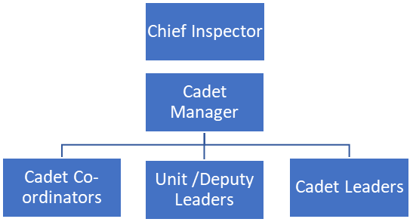

(b) Staff who work directly for this post

None
- MAIN RESPONSIBILITIES

INPUT |  |  | OUTPUT
As leader: provide support, act as chaperone, supervise and provide guidance to Cadets, Cadet sessions and events. |  |  | Ensure a cohesive approach to the management of Cadets, their development and welfare.  Accompany Cadets at events so they can participate.  Post holder becomes part of the Policing family.
Deliver the National Volunteer Police Cadet programme. |  |  | Ensure a consistent approach of delivery, working in the spirit of National Guidance. Efforts will be focused and provide meaningful outcomes.  Research and prepare topics and activities inline with the National Programme
Provide safeguarding, support, supervision and guidance, ensuring the welfare and development of Cadets is a priority |  |  | Effective management of child protection issues, in line with the adopted national VPC Safeguarding Policy and the Dorset Force referral process. Inspire young people to become good citizens and build their confidence as they become young adults
Maintain strong links with the local Police Neighbourhood Inspector |  |  | A strong relationship between the Cadet Unit and the local Neighbourhood Policing Team (NPT) is vital. Cadets are a useful asset and resource to NPT’s through social action, connectivity and neighbourhood tasking; for crime reduction or prevention activity
Assist with social media outlets, newsletters, presentations, role plays and good news stories |  |  | Raise the profile of the Cadet Unit, improving public confidence in the Volunteer Police Cadet scheme and Dorset Police
Engage with local partnerships; organisations; local authorities, and, youth services; effectively representing Dorset Police in a diverse and multi-agency setting |  |  | All opportunities can be maximised; stronger relationships developed, and service levels improved
Communication with Cadets using the Marshall Message Board |  |  | Work as a team to achieve objectives effectively and provide good communication and engagement with the Cadets.
With other Cadet Leaders share administration and record keeping, through the utilisation of personal strengths and skills |  |  | Accurate recording Cadet Leader outputs to ensure detailed performance reports can be produced.
4. MAIN CONTACTS

1. | Cadet Manager and Cadet Coordinator
2. | Local stakeholder (as per designated location)
4. | Dorset Police officers including the Special Constabulary
  - SPECIAL CONDITIONS

The post holder must:
- Be 18 years or over.
- Undertake relevant training, which must include mandatory Safeguarding and Safety training.
- Reliability to ensure that there is always the correct ratio of Cadets Leaders to Cadets are maintained.
- Comply with Dorset Police policies, procedures, and Code of Ethics both in service delivery and the treatment of others.
- Comply with legislation, and especially the Data Protection Act 2018; thus, ensuring the confidentiality of information.

This post is subject to vetting and DBS checks.

6. KNOWLEDGE AND SKILLS
Essential |  |  |  | Desirable
- Volunteer flexibly, including essential evening work and some weekends.  - Good communication and interpersonal skills  - Ability to plan and prioritise.  - Good I.T skills and record keeping.  - Integrity, reliability and self-discipline.  - Understand, and adhere to, matters of Equality and Diversity |  |  |  | - Experience of youth work  - Full driving licence  - Full Driving licence including Category D1
- ADDITIONAL INFORMATION

Police Support Volunteer shifts are to be agreed locally. There is an expectation in line with the Volunteer policy that 6 hours volunteering is undertaken each month, supporting weekly Cadet evening sessions and some weekend events.

Cadet sessions are typically held once a week, for 2 hrs during the evening; (exact time and day of the week will be specific to the designated unit and venue).

Sessions will generally not take place during standard school holidays; however, volunteering activities should continue. Meetings and events can be held at other times, including weekends.
Volunteers who undertake driving duties will be subject to a driving assessment by the Alliance Driver Training Unit

8. TERMS OF APPOINTMENT
In accordance with the current Dorset Police Volunteers Policy

